🐧 Understanding the Linux Directory Structure — A Complete Guide for Beginners
Linux may look overwhelming at first, but once you understand its directory structure, everything becomes easier — from navigating the system to managing files, installing packages, writing scripts, and even troubleshooting servers.

Unlike Windows (which uses drives like *C:*, *D:*), Linux has a single unified directory tree, starting from the root / directory.
- The Linux directory layout follows the Filesystem Hierarchy Standard (FHS).
- This standard defines how directories are organized and what types of files should be stored in each.
- Since Linux is based on UNIX, it inherits many of UNIX’s filesystem conventions.
- Similar directory structures are also found in other UNIX-like operating systems such as BSD and macOS.
🌳Types of files in the Linux system
Linux categorizes files into different types based on their purpose, such as general data storage, system structure, or device representation.

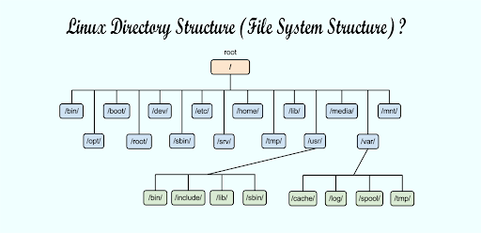

👉Top-level directories associated with the root directory
These top-level directories under the root (/) form the foundation of the Linux file system, each serving a specific role in organizing system files, user data, and configurations.
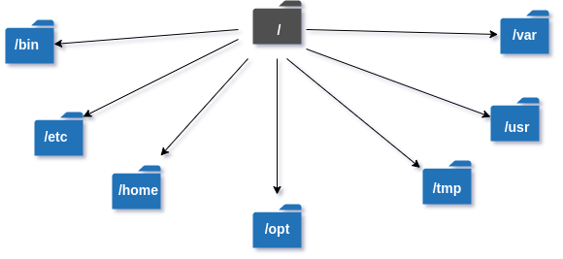
👉/ — Root Directory
The top-most directory of the Linux filesystem. Every file and folder in Linux starts from here.
All other directories are children of /.

👉/bin — User Binaries
Contains essential command-line programs used by all users.
Includes basic commands like ls, cp, mv, cat.
If /bin is missing, the system cannot work normally.

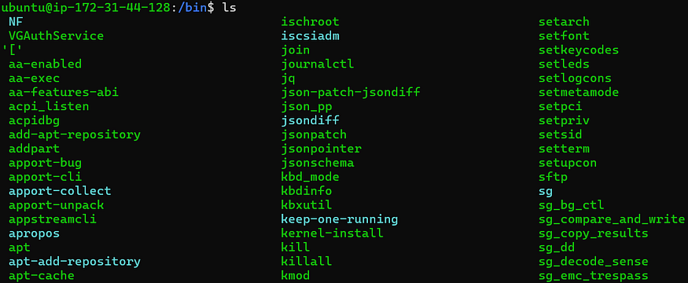

👉/boot — Boot Loader Files
Contains essential files required to start (boot) Linux.
Includes the kernel (vmlinuz) and GRUB configuration files.
If this directory is damaged, the system won’t boot.

👉/etc — Configuration Files
The main configuration directory for the system.
Stores settings for services, users, networks, and applications.
Files here control how the system starts and behaves.

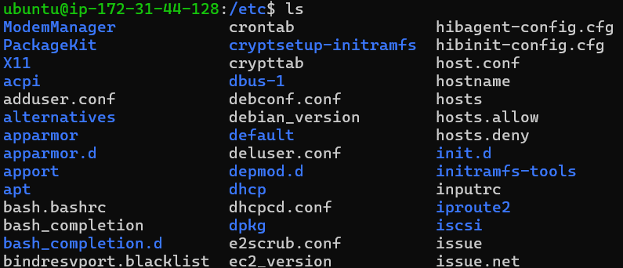

👉/lib
Stores shared libraries needed by essential programs in /bin and /sbin.
Works similarly to “DLL files” in Windows.
Without these libraries, commands cannot run.

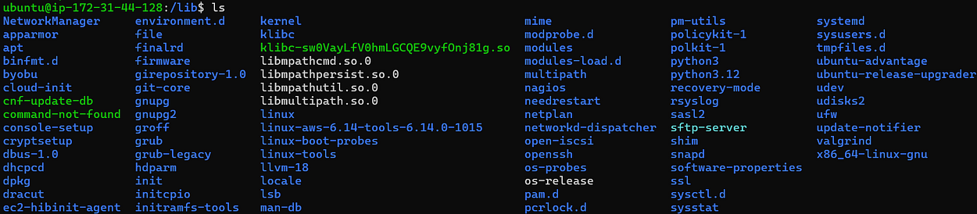

👉/lib64
Contains 64-bit versions of essential system libraries.
Used on 64-bit Linux systems for compatibility.
Supports both system binaries and applications.

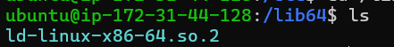

👉/media
Automatically mounts removable media like USB drives, CDs, or external disks.
Each device gets its own folder inside /media.
Very user-friendly for detecting and accessing external devices.

👉/opt
Stores optional or third-party applications that are not part of the core system.
Examples: Google Chrome, VMware, custom software.
Keeps external packages separate from system-managed files.

👉/root
Home directory of the root (superuser) account.
Contains root’s personal configuration and files.
Accessible only by the system administrator.

👉/sbin
Contains system administration commands.
Used for booting, repairing, and configuring the system.
Includes tools like fdisk, ifconfig, reboot, etc.

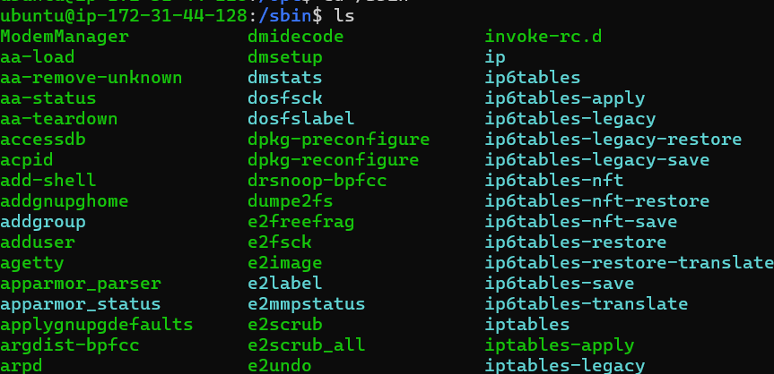

👉/snap
Used by the Snap package manager (Ubuntu-based systems).
Stores installed snap applications and their versions.
Allows sandboxed and auto-updating software.

👉/sys
A virtual filesystem that provides information about the kernel and hardware.
Used for device management, drivers, and kernel tuning.
Reflects real-time hardware data.

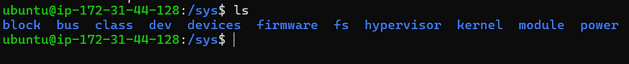

👉/usr
Contains user software, libraries, documentation, and utilities.
Includes /usr/bin, /usr/sbin, /usr/lib.
Usually the largest directory on the system.

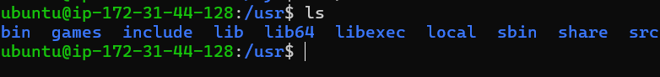

👉/bin.usr-is-merged
A symbolic or compatibility link created in merged-/usr systems.
Indicates that /bin is actually merged with /usr/bin.
Used in modern Linux distributions for unified filesystem layout.

👉/dev
Contains device files representing hardware (disks, USBs, terminals).
Example: /dev/sda, /dev/tty, /dev/null.
Allows Linux to treat hardware devices like files.

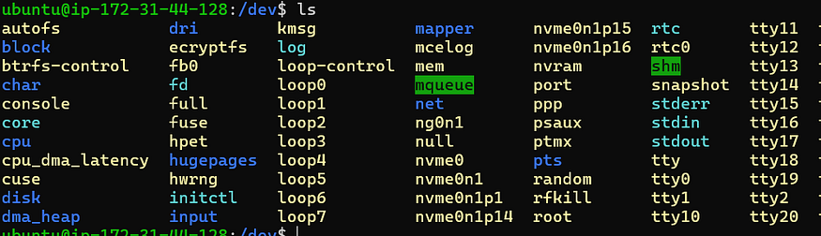

👉/home
Stores personal files, documents, and settings for all normal users.
Each user has a folder inside /home.
Acts like the “Users” folder in Windows.

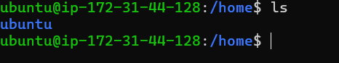

👉/lib.usr-is-merged
Indicates that /lib has been merged with /usr/lib.
Used in modern Linux systems to simplify directory structure.
Helps reduce duplication and standardize paths.

👉/lost+found
Created by the filesystem for recovering corrupted or lost files.
Used mainly after system crashes or disk errors.
Common in ext4 and similar Linux filesystems.

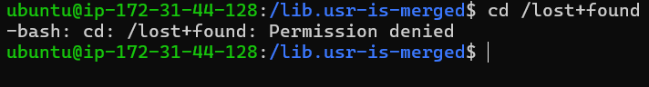

👉/mnt
A temporary mount point for system administrators.
Used to manually mount disks, network drives, or partitions.
Does not auto-mount like /media.

👉/proc
A virtual filesystem containing real-time system and process information.
Includes CPU, memory, and running process data.
Used heavily for monitoring and debugging.

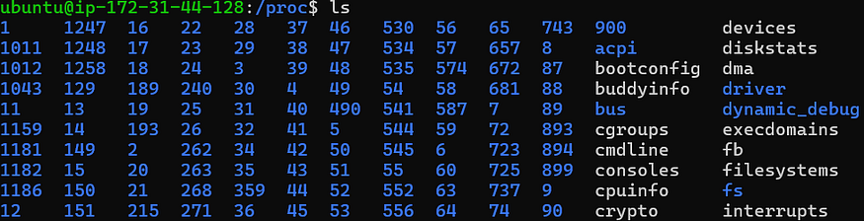

👉/run
Stores runtime data such as PIDs, sockets, and service state.
Data here is temporary and cleared on reboot.
Used by systemd and active services.

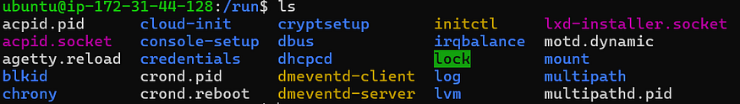

👉/sbin.usr-is-merged
Indicates /sbin is merged with /usr/sbin.
Part of merged-/usr modernization.
Ensures all admin tools reside in /usr.

👉/srv
Stores data used by system services and servers.
Example: web server files, FTP data, or repository data.
Used primarily on server systems.

👉/tmp
Holds temporary files created by applications or users.
Files here are deleted on reboot or automatically over time.
Useful for installers, editors, and temporary caching.

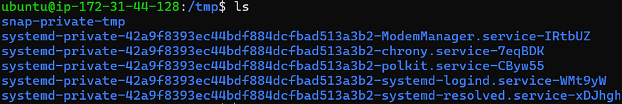

👉/var
Contains variable data such as logs, caches, database files, and spool data.
Example: /var/log, /var/mail, /var/lib.
Changes frequently and is crucial for troubleshooting.

